Health and Safety Assessment Report  Purdy Solar  65 MW_{AC} Photovoltaic Facility  Greensville County, VA | Abstract  This is an assessment of the potential health and safety impacts of the proposed 65 MW_{AC} Purdy Solar photovoltaic facility in Greensville County, VA. The assessment evaluates potential positive and negative impacts on public health and safety by considering the project design, equipment specifications, and operations. The conclusion of the assessment is that the Purdy Solar project will not create negative health and safety impacts. The clean electricity the project will produce will reduce the burning of fossil fuels, which will reduce pollution from those sources and provide millions of dollars’ worth of local public health benefits as a result.  Tommy Cleveland, PE  Consulting Engineer  Solar Health and Safety Expert  January 18, 2022 (original)  March 18, 2024 (Revision 1) (updated to remove batteries)

Health & Safety Assessment Report
  - Purdy Solar – Greensville County, VA

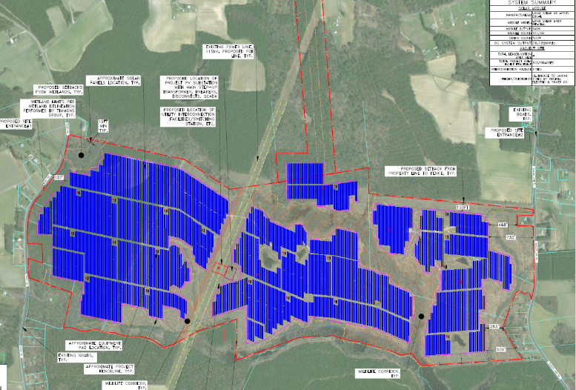
Project Overview:
- Project Name: Purdy Solar
- Developer: Palladium Energy with Renewable Energy Services
- Capacity: 65 MW_{AC} (~76 MW_{DC})
- Project Area: ~311 acres inside the fence
- Solar Panels: bi-facial crystalline silicon, LONGi Solar 540W or equivalent
- Structure: single-axis trackers (north-south rows, 60° E to 60° W)
- Inverters: central station type (~2-5 MW each)
- Battery Energy Storage: none
- Point of Interconnection: Virginia Electric & Power Co. Clubhouse-Jarrett 115 kV transmission line near center of project
- Interconnection Equipment: Virginia Electric & Power Co. switchyard and 34.5kV/115kV project substation

Report Author
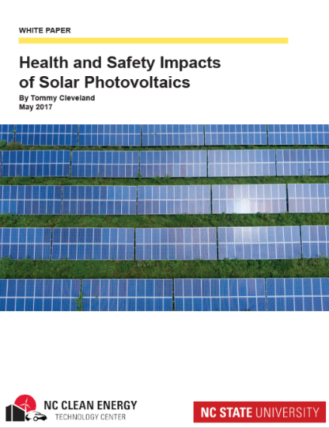
The author of this report is Tommy Cleveland, PE, a consulting engineer licensed as a professional engineer in NC since 2007 and licensed in VA since 2021. Mr. Cleveland graduated from North Carolina State University with undergraduate and master’s degrees in mechanical engineering, where he focused on energy. His solar career started with his master’s thesis, which led to working over 12 years at the North Carolina Clean Energy Technology Center at NC State University. While at the university Tommy worked on nearly every aspect of solar energy; from teaching, to testing equipment, to system research & development, to leading a statewide stakeholder group in the development of a template solar ordinance. During his time at NC State, North Carolina installed more photovoltaic (PV) capacity than any state other than California, mostly in the form of 3-5 MW_{AC} utility-scale solar facilities covering around 40 acres each. Utility-scale solar was new in the US and unfamiliar to the hundreds of communities around the state where the systems were proposed, and many of those communities had questions about the technology and its potential to harm public health or the environment in their community. Many of those questions found their way to Mr. Cleveland and he expanded his already broad knowledge of photovoltaics to research and find answers to the questions being asked. Over time he became an expert on the potential health and safety impacts of photovoltaics and was the lead author of the 2017 NC State white paper on the topic. Since mid-2017 Mr. Cleveland has worked as a solar engineer at an energy engineering firm conducting interconnection commissioning of utility-scale solar and battery facilities for utilities in North and South Carolina. In this role Mr. Cleveland was the engineer responsible for (interconnection) commissioning over 60 solar sites and 4 battery sites.

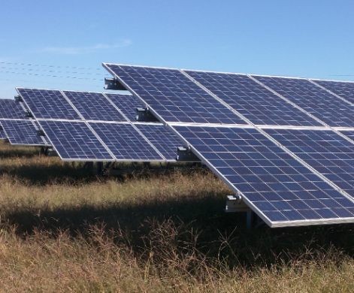
Executive Summary
This report assesses the potential health and safety impacts of the proposed Purdy Solar 65 MW_{AC} solar photovoltaic project. The Purdy Solar facility, located in Greensville County, Virginia, will install crystalline silicon solar panels on single-axis tracking racks that slowly rotate each row of panels to follow the sun across the sky. Large central station inverters will convert the DC solar electricity generated by the solar panels into grid-synced AC electricity. Transformers will boost the voltage for connection to an onsite substation that connects to a transmission power line running through the project.
Photovoltaic panels are not new. They have been used and studied for over 40 years and are well understood by the scientific community. Utility-scale solar facilities are newer, but they too have been installed and studied for over a decade, and scientists also have a clear understanding of their function and impacts.
Photovoltaic systems produce emission-free electricity. This replaces electricity production from fossil fuel power plants that produce harmful emissions. The health benefits of clean solar electricity are hard to put a dollar figure on, but the EPA’s best attempt at doing just that puts the value in the mid-Atlantic US between 3.1 and 7.0 cents per kWh produced. Even at the bottom end of this range, this equates to approximately $3.9 million of public health benefit per year for the Purdy Solar project, and over $116 million in 30 years.
The only risks to health and safety of the Purdy Solar project are not unique to solar but exist for any source or use of electricity. These are electric shock, arc flash, and fire. Due to world-class safety regulations in the U.S. and an experienced solar industry, these risks are extremely low, and the secure and isolated nature of ground-mounted PV facilities, including Purdy Solar, results in negligible risk to the public.
Common concerns about toxicity and EMF from solar facilities are understandable, but the operating characteristics and materials present in the equipment means that neither toxicity nor EMF pose a material risk to public health or safety. Research and experience regarding heat island effect shows that, like other utility-scale PV projects, the Purdy Solar project will not create either of these impacts. The single-axis trackers at Purdy Solar that will keep the panels facing in the direction of the sun minimizes the potential for the project to create any glare.
When the solar panels reach the end of their useful life, likely in 30 to 40 years, they will be removed from the site and disposed of in conformance with federal, state, and local requirements, which could mean recycling or disposal in a landfill. Today the main constituents of the solar panels, and the other equipment such as racking and transformers, can be recycled in the existing recycling infrastructure. Technology to recycle nearly all the constituents in solar panels exists today and is expected to be much cheaper and widely available when the solar panels at this project reach the end of their useful life.
Based on my knowledge of engineering and science, personal experience with PV technology, review of academic research, and review of project materials provided by Renewable Energy Services and Palladium Energy my findings and opinions are summarized as follows:
- The Purdy Solar project will result in a meaningful reduction of regional air pollution.
- The Purdy Solar project will not result in any negative impacts to public health or safety.
- The Purdy Solar project will not increase the temperature of the area surrounding the site.
- The Purdy Solar project is not expected to create any glare hazards or other negative glare impacts.

Introduction

Purpose:
This report assesses the potential health and safety impacts of the proposed Purdy Solar (“Purdy”) 65 MW_{AC} solar project. It also seeks to educate readers on the health and safety impacts of photovoltaic systems using accurate scientific sources of information, including providing resources for further reading.

Overview of Potential Impacts:
The proposed solar photovoltaic (PV) system is likely to remain in operation at least 30 years, and this report considers its potential impacts in Greensville County from the start of construction onward, including decommissioning of the project and restoration of the land. This assessment considers all aspects of the project but focuses on those unique to solar projects.

Potential Positive Health and Safety Impacts:
Every utility-scale PV project significantly reduces pollution by producing emission-free electricity that replaces electricity that otherwise would have been largely produced by burning coal and natural gas. Burning these fossil fuels for electricity production is a significant source of air, water, and soil pollution, so reducing their use is a clear public health benefit.
The US Environmental Protection Agency (EPA) conducted a study to determine how much pollution PV systems save and to estimate the public health value of the cleaner air, water, and soil they provide. These experts calculated that in the mid-Atlantic states, based on the sunshine available, the way electricity is produced, and the public health impacts of fossil fuel-fired electricity, every kilowatt-hour (kWh) of solar electricity produced provides 3.1 to 7.0 cents of public health benefit. At this rate of benefit, the Purdy Solar project will produce $3.9 - $8.7 million of public health benefits every year, which would add up to $116 - $261 million over the life of the project. The public health benefits of generating pollution-free electricity with PV are very significant.
The positive benefits of photovoltaics are widely understood and well documented, so this report will not address them further. Furthermore, the positive public health impacts of the Purdy Solar project significantly outweigh any health and safety risks as described below.

Potential Negative Health and Safety Impacts:
While PV facilities, as electricity generating facilities, in general provide some potential for negative health and safety impacts, the Purdy Solar project does not present any negative health and safety risks specific to its location or technology choice. The only aspect of PV systems that presents risk of physical harm is the potential for electrical shock, arc flash, or fire, which are hazards present with any electrical system and not unique to solar. There are several other aspects of PV systems that often raise public health and safety concerns, but no other aspect of PV systems poses more than an insignficant risk of negative public health or safety impacts.
The review and permitting process Virginia requires for utility-scale solar projects provides some certainty that the proposed project will not cause significant environmental or health impacts. The Virginia Department of Environmental Quality (DEQ) coordinates reviews from the Department of Historic Resources, the Department of Wildlife Resources, and the Department of Conservation and Recreation to ensure potential significant impacts to cultural or threatened and endangered species are avoided or mitigated. These reviews ensure the project complies with state regulations for small renewable energy projects (up to 150 MW). The site is not authorized to begin construction until DEQ completes this review and provides authorization. Additionally, the project must comply with all other applicable local, state, and federal statutes and regulations, including but not limited to, strict adherence to applicable state and local erosion and sediment control/storm water management laws.
This report will address all the potential health and/or safety risks of the Purdy Solar project, including common concerns that have no potential for public health impact. Specifically, this report addresses the following possible negative impacts/concerns:

- Electrical Shock and Arc Flash
- Fire and Emergency Response
- Toxicity / Chemical
- Electromagnetic Fields (EMF)
- Heat Island Effect
- Glare

To meet the Greensville County solar ordinance, Purdy Solar will include a 150 ft setback from neighboring property lines and will be significantly screened from the ground-level view of adjacent properties by a buffer zone at least 100 feet wide containing a planted vegetative screen and/or existing vegetation or natural landforms. This is a large setback buffer compared to many solar facilities and most other land uses, and multiple rows of vegetative screening is very uncommon around existing solar facilities and many other land uses. This combination of significant setback and thick vegetative screening will separate the public from this project and minimize its impacts, including the visual/aesthetic impact of seeing the equipment.
The Greensville County solar ordinance also gives the county authority to shut down and remove the solar facility if it is declared to be unsafe by the zoning administrator or building official and not brought into compliance within fourteen days.
Before addressing each of these impact categories, this report provides an overview of utility-scale photovoltaic equipment and facility construction and operations. These photos should help introduce utility-scale PV to any reader who has not toured a facility during construction or operation.

Equipment, Construction, and Operations
To understand the potential impacts of a utility-scale PV system it is helpful to understand the components of the facility, as well as how a facility is constructed and maintained. The components and practices in this overview are typical of the industry and representative of the proposed Purdy Solar project. The initial site work occurs first, but the order of the other construction steps is flexible and may occur concurrently.
Initial Site Work (construction entrance/driveway, sedimentation and erosion control installation, clearing and grubbing, potentially some grading, perimeter fence, and internal roads)
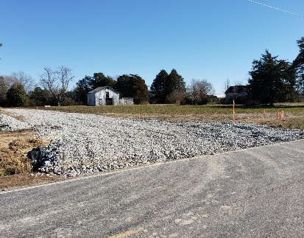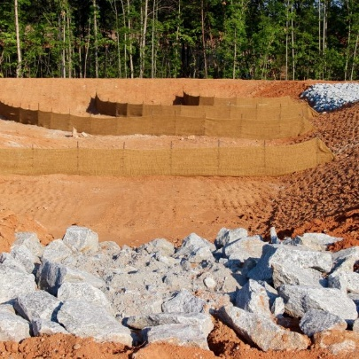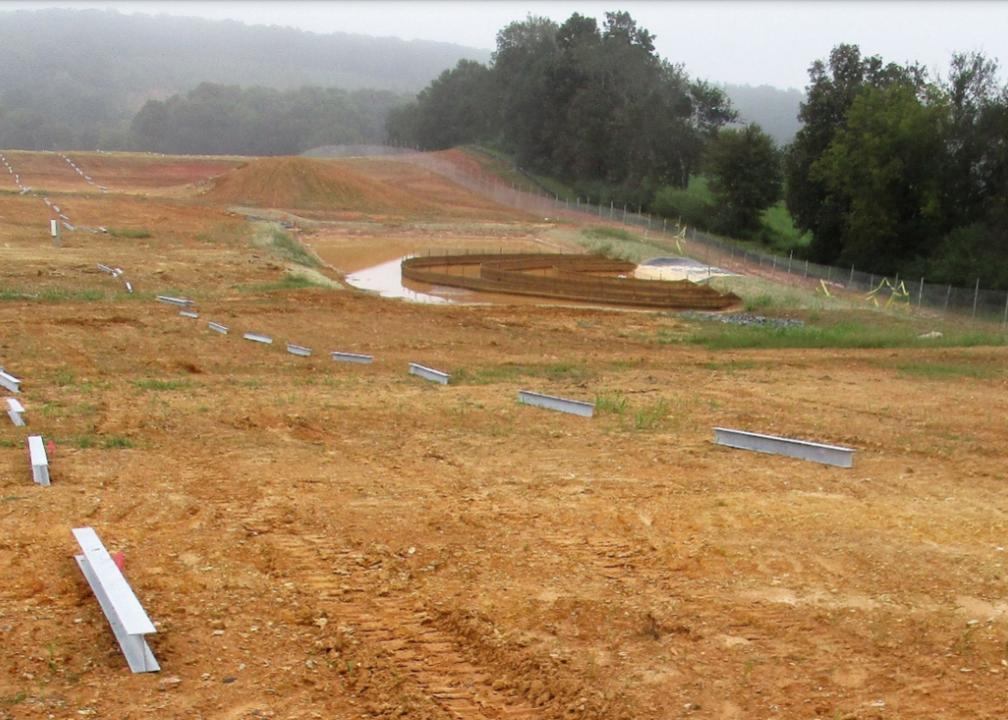
Underground Work (trenching for wires from PV combiner boxes to inverters, inverter pad installation, medium voltage cables to interconnection equipment)
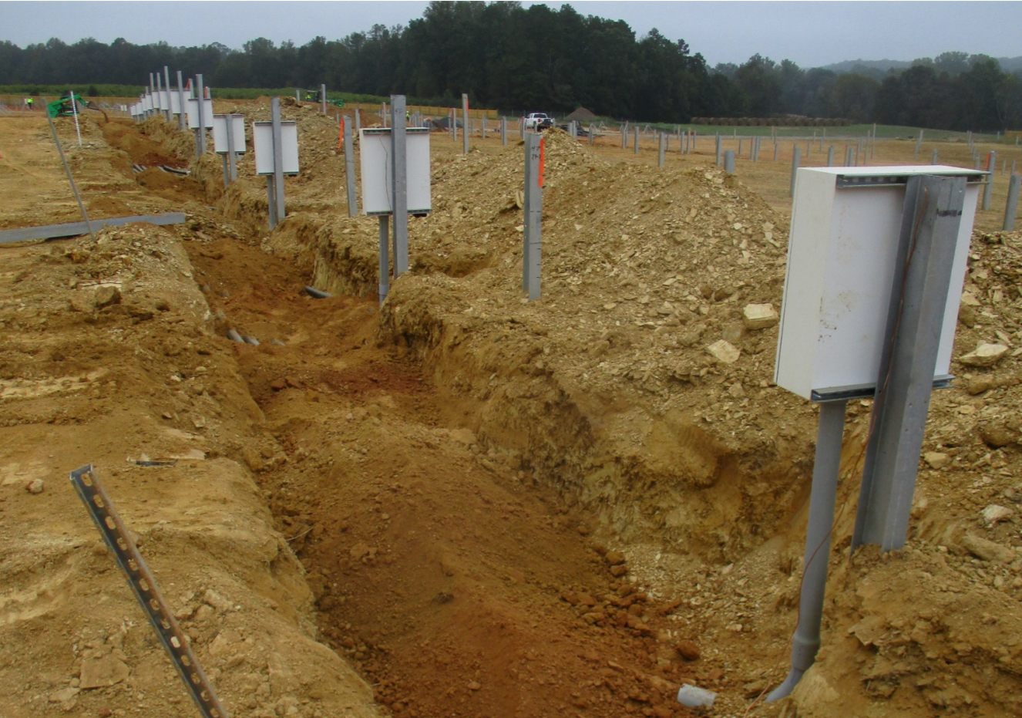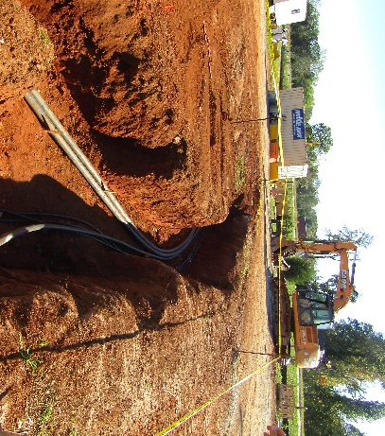
PV Panel Structure/Racking (driving of steel piles, installation of racking “tables”, installation of PV panels)
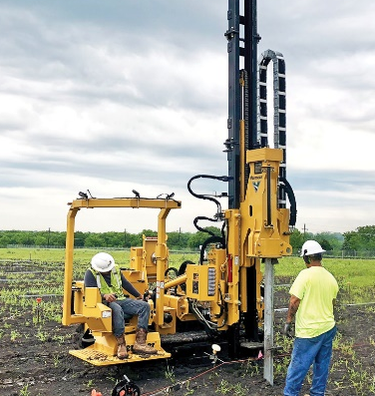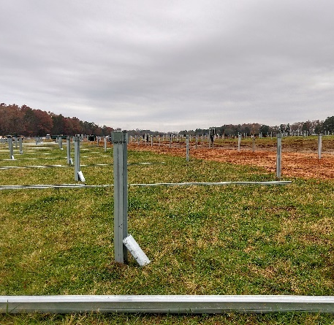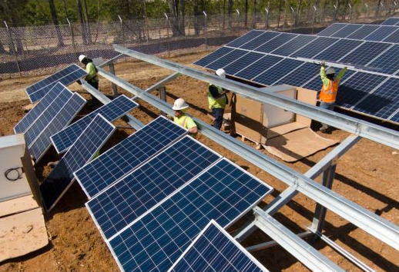
Electrical Work (connection of PV module wiring, combiner boxes, inverters, transformers, interconnection facilities)
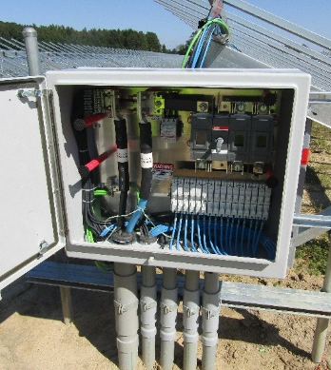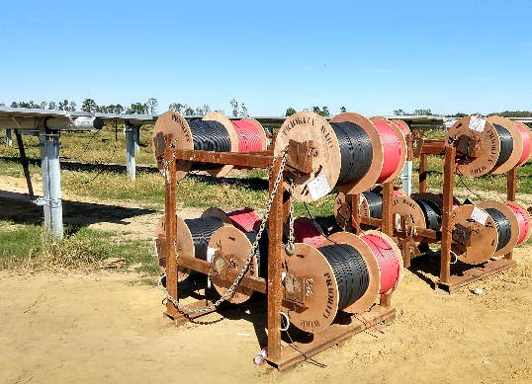
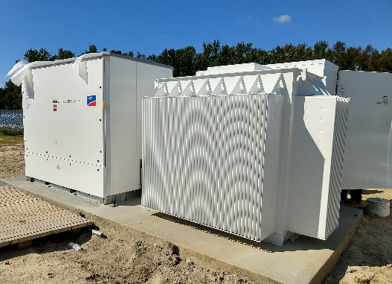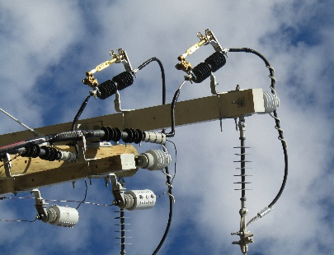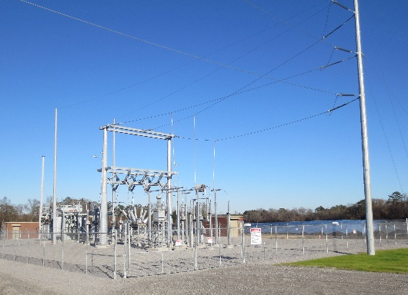
Establishment of Ground Cover (required to close out sedimentation and erosion control permit)
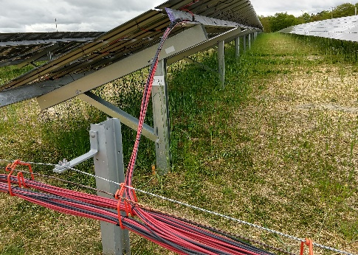
Operations and Maintenance (24/7 monitoring, vegetation maintenance, preventative maintenance)
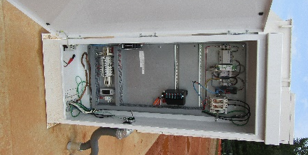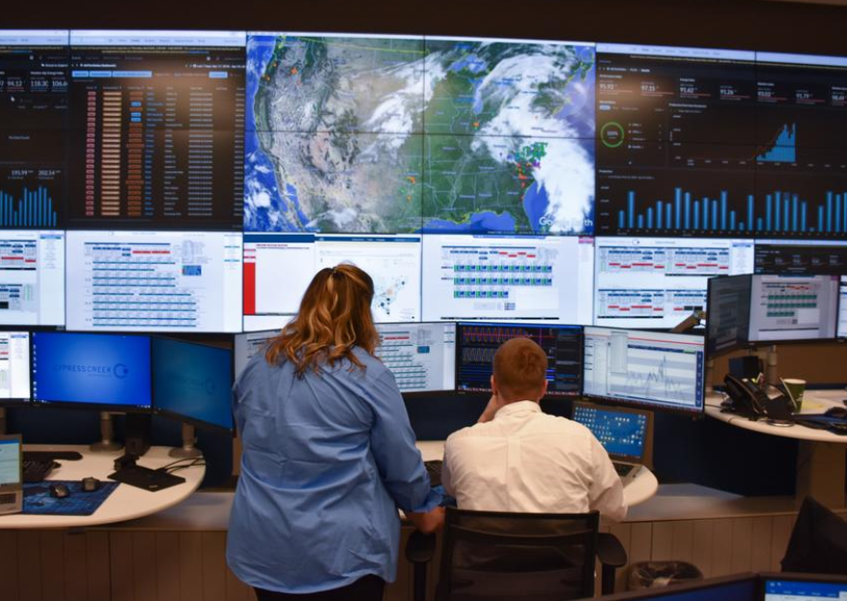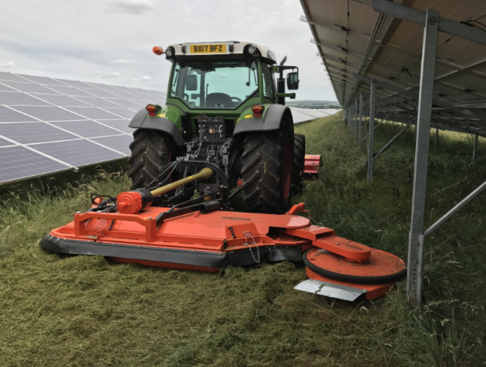

Electrical Shock and Arc Flash
Any electricity over 50 volts presents an electrical shock hazard, including the electricity in PV facilities. However, like electrical systems in buildings, the solar facility must adhere to the National Electrical Code (NEC) and the equipment must be certified to the appropriate UL safety standards. Unlike buildings, members of the public are restricted from entering a utility-scale solar facility. To help ensure that only qualified people have access to the equipment, the NEC requires a perimeter security fence with electrical warning signs. The lack of public access coupled with the high U.S. electrical safety standards greatly reduces the risk of electric shock for the public.
In circuits with significant available fault current there is another electrical hazard, called arc flash, which is an explosion of energy that can occur due to a short circuit. This explosive release of energy causes a flash of light and heat, and creates a shockwave that can knock someone off their feet. The risk of arc flash in a solar facility is no different than the risk at commercial or industrial buildings, except that solar facilities are much less accessible. Equipment with an arc flash risk require arc flash warning labels, and only trained personnel wearing the proper personal protective equipment are allowed to work on it. Due to the secure perimeter and the high U.S. electrical safety standards, there is extremely low arc flash risk to the public.
Figure 1. Perimeter Fence with Warning Signs

Fire and Emergency Response
Every electrical system has some risk of starting a fire, including electrical systems in residential, commercial, and industrial buildings. It is this hazard that motivated creation of the National Electrical Code (NEC) over 100 years ago. Due to the high standard required by the NEC, modern electrical systems rarely start fires. Like electrical systems in buildings, photovoltaic systems must also adhere to the NEC. In the rare case that a PV system has a fault that starts a fire, there is very little combustible material present for it to ignite. The only flammable portions of PV panels are the few thin plastic layers, the plastic junction box, and the insulation on its wires.
Heat from a small flame is not adequate to ignite a PV panel, but an intense fire or an electrical fault can ignite a PV panel. One real-world example illustrating the low flammability of PV panels occurred during July 2015 in an arid area of California. Three acres of grass under a utility-scale PV facility burned without igniting the panels mounted just above the grass. Another example occurred recently in Florida, where there was a 5-acre grass fire under a portion of a 400-acre PV facility that did not ignite any modules.
The most significant fire hazard at a utility-scale solar facility may be the oil in the transformers. There are medium voltage transformers dispersed throughout the site located by each inverter, and there is a large transformer in the interconnection substation. Traditionally these types of transformers have been filled with a mineral oil, which is derived from petroleum. The mineral oil is electrically insulating but flammable. These transformers are similar to transformers found throughout every community; at shopping centers, schools, factories, neighborhoods, etc. There are best practices for how to prepare for and conduct an emergency response at a transformer. For example, see the NERC “Lessons Learned” document in the Sources for Further Reading at the end of this section.
No special equipment is required to respond to a fire incident at a utility-scale PV facility. The most important thing for first responders to know is that as long as the sun is shining on the PV panels they will produce dangerous voltage, but there is no danger in touching undamaged panels. There are multiple electrical disconnect switches in PV systems which allows problem areas to be electrically isolated quickly.
Risks of fire associated with ground cover and perimeter vegetation are reduced by landscaping plans that are developed with this specific goal. Local emergency responders will have 24/7 access to the facility via a lock box or key. First responders can safely extinguish grass fires inside of the facility, or monitor and protect the areas surrounding the facility, to ensure the fire does not spread to surrounding areas. The solar facility owner remotely monitors the system around the clock and has personnel available 24/7 for emergencies. The International Association of Fire Fighters (IAFF) provides online training on responding to fires at photovoltaic facilities at www.iaff.org/solar-pv-safety.
Sources for Further Reading on Fire and Emergency Response:
- Duke Energy: Fire Safety Guidelines for Rooftop- and Ground-Mounted Solar Photovoltaic (PV) Systems, September 2015
- North American Electric Reliability Corporation (NERC): Lessons Learned, Substation Fires: Working with First Responders, February 2019

Toxicity (Equipment and Operations)
Toxicity is probably the most common health and safety concern about photovoltaic systems, although as detailed below the systems do not pose a material toxicity risk to the public or the environment. This report examines all possible sources of toxicity, from site construction to decommissioning at the end of the project life. The potential sources of toxicity are organized into two categories: equipment and operations and maintenance (O&M).

Toxicity: Equipment
The main equipment installed at a solar facility includes photovoltaic modules (aka solar panels or PV panels), metal structures for mounting the solar panels, and wiring to collect the electricity they produce. The other major components are inverters and transformers. Inverters are enclosed power electronic equipment that do not contain liquids and are treated like other electronic waste (e-waste) at the end of their life. Transformers contain non-toxic mineral or vegetable oil and are no different than the typical utility transformers outside of most schools and shopping centers. Solar panels have raised the most public concerns related to toxicity, so they are the only component addressed in this section on solar equipment.

Contents of PV Panels
The Purdy Solar project will use crystalline silicon PV panels from a Bloomberg Tier 1 manufacturer. The PV panels are the most expensive and most important component in a solar facility, so the project owner performs industry-standard due diligence to ensure that the panels selected and delivered to the project are properly manufactured, certified, and tested.
The diagram below shows the components of a typical silicon PV panel, including a close-up of the solar cells and the electrical connections between each cell. Over 80% of the weight of a PV panel is the tempered glass cover and the structural aluminum frame, which work together to create a strong, durable panel that outlasts its 30-year performance warranty. The encapsulation films are clear plastic lamination layers that protect the PV cells and electrical contacts from moisture for the life of the panel. These layers also maintain the panel as a single unit in the event of breakage of the tempered glass front cover, similar to the film in auto windshields that keeps them from fragmenting if the windshield shatters.
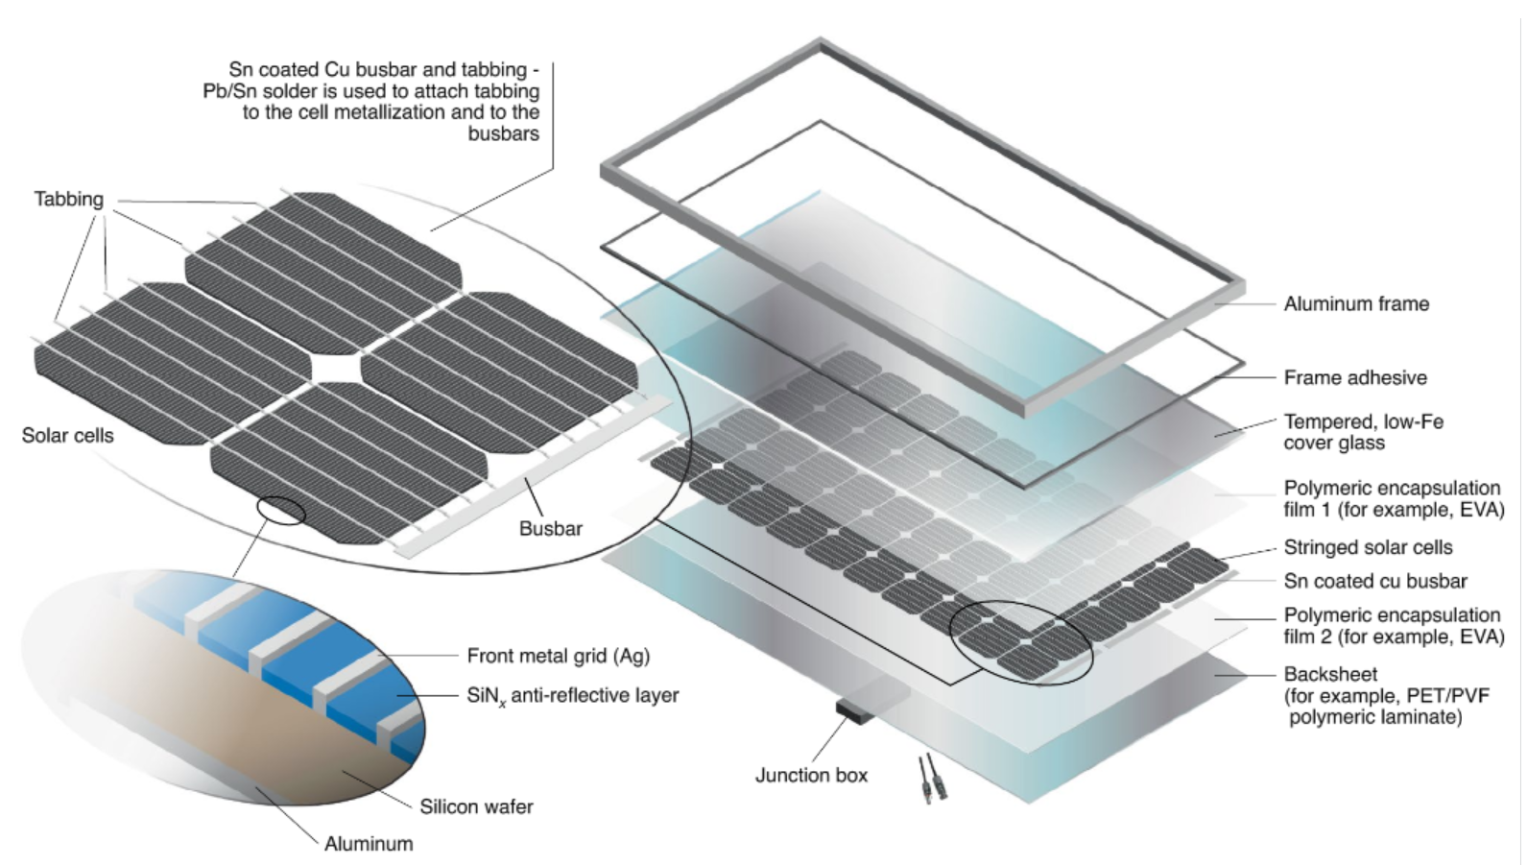
Figure 3. Contents of Framed Crystalline Silicon Panels (Source: NREL)

As can be seen in the above diagram, there are no liquids to leak from a broken panel. The plastic layers are inert. The silicon PV cells are nearly 100% silicon, which is harmless and is the second most common element in the Earth’s crust. The only components of a PV panel that have any potential of toxic impact is the solder used to connect the solar cells together and to the busbars at the end of the panel, and the thin strips of silver that collect electricity from each cell. The solder, which is the same tin-lead solder standard in the electronic industry, is 36% lead. The tiny amount of silver in a panel does not create a toxicity hazard, but it does add potential recycling value.
Even though there is only a tiny amount of lead in each panel, the total amount of lead in all the PV modules in a utility-scale project adds up to a considerable amount of lead. However, these PV panels are spread out over a large area and when the amount of lead in the PV panels is compared to the amount of lead naturally occurring in the soil under the PV array it is obvious that even if all the lead somehow leached out of every module (which as explained below is impossible) the increase in total lead in the soil would be less than the naturally occurring difference between different soils. Across the US, soils naturally have between about 10 and 50 mg of lead per kg of soil, with the average being somewhere in the 20s. Across the 66 USGA survey locations in VA, the values ranged from 7.7 to 153 with an average of 27 and a median of 21. For a location that naturally has 20 mg of lead per kg of soil, all the lead in all the PV modules in the facility would have the same amount of lead as just the top 2.5 inches of soil at the site!

Broken PV Panels
There is zero risk of toxicity escape from undamaged PV panels because any lead is sealed from air and water exposure. Individual panels damaged during the life of the solar facility are identified in days to months through either remote monitoring of system performance or from visual inspections during maintenance by onsite staff. Recently an international team of experts conducted an International Energy Agency - Photovoltaic Power Systems Programme (IEA-PVPS) study to assess if there is a public health hazard caused by lead leaching from the broken PV panels during the life of a utility-scale solar facility utilizing conservative assumptions to evaluate extreme scenarios. The study examined worst-case exposure routes of soil, air, and ground water for a typical 100 MW_{AC} PV facility. For example, the worst-case residential groundwater exposure assumed that all broken panels from the entire array were within 25 feet of the groundwater well, and the chemicals released from every broken panel transported to the same groundwater well. The study found that worst-case lead exposure via air, soil, and water were each orders of magnitude less than the levels defined by the US Environmental Protection Agency (EPA) to have no adverse health effects. In the case of water, the health-screening level is the same as the maximum concentration level (MCL) set by the EPA for water quality in public water systems. This study demonstrates that there is no risk to public health from lead leached from broken PV panels.
Figure 4. Close-up photo of impact point that broke the glass front of this PV panel

PFAS
Some solar opponents have raised questions about the possibility of per- and poly-fluoroalkyl substances (“PFAS”) chemicals being emitted by solar panels. PFAS chemicals are a group of man-made chemicals informally known as “forever chemicals” due to their durability in the environment. These chemicals have been used in many industrial and consumer products for over 60 years, including food packaging materials, firefighting foam, waterproof clothing, and stain resistant carpet treatments.
As explained in a fact sheet from the University of Michigan entitled “Facts about solar panels: PFAS contamination”, PV panels do not contain PFAS materials. Neither the self-cleaning coating on top of the solar panel, the adhesives in the panel, nor the front or rear covers/substrates contain PFAS. The “backsheet”, or traditional rear substrate of a silicon PV panel, is the thin plastic layer on the rear of a single-glass PV panel that provides electrical insulation and physical protection for the rear of the PV cells. Polyvinyl fluoride (PVF) is the base material for the most common backsheet material (Tedlar), but several other materials have also been used as backsheets, some consisting of multiple layers. Depending on which definition of PFAS that is used, PVF may be classified as PFAS, however the most recent and applicable definition of what is and is not a PFAS material was created by the Organization for Economic Co-operation and Development (OECD) in 2021 and PVF does not meet this modern PFAS definition. The bi-facial panels planned for Purdy Solar do not have a backsheet at all, but rather have a sheet of glass to protect the rear of the panel and to allow sunlight to the rear of each PV cell, so these panels do not contain PFAS, under any definition of PFAS.

PV Panel End-of-Life
PV panels last a very long time, but they do not last forever. Their output declines slightly each year, but panels rarely fail in less than 40 years. The expected economic life of utility-scale PV panels is 25-40 years, at which point they may be replaced by new panels or the entire project may be decommissioned, bringing the land back to how it was before the solar facility was installed. In both instances, the original PV panels are removed from the site. The Greensville County ordinance requires that Purdy Solar guarantee that decommissioning funds are available by depositing the needed funds in an escrow account approved by the County, so in any worst-case scenario the County will have the funds required to properly decommission the site. There are three possible fates for solar panels at the end of their economic life at a project:
- Reuse: It is most likely that when the PV panels at the Purdy Solar project are decommissioned, they will still produce approximately 80% of their original output and have another decade of productive life, making them viable to be reused as solar panels in certain situations, likely in developing countries.
- Recycling: Any panels that are not reused as working panels could be recycled. Currently in the US it is possible to recycle the largest constituents of PV panels using the existing glass and metal recycling infrastructure. Today this recycling comes at a cost premium to disposing the panels in a landfill. However, as PV recycling technology improves and the number of panels reaching end-of-life increases dramatically, it is possible that in the future recycling PV panels will more than pay for itself. Recycling plants built specifically to recycle PV panels can recycle nearly 100% of the panel, including the valuable silver and refined silicon they contain, and can be optimized for the task, significantly reducing the cost to recycle each panel. In 2018 the first industrial-scale PV-specific recycling plant was built, in France, and in 2022 the first large scale PV recycling plant in the US was built. These initial PV recycling plants will not have the capacity to recycle the millions of installed PV panels, but in the coming decades it is expected that PV-specific recycling plants will become much more commonplace. PV recycling technology is clearly still in its infancy. However, it is expected that when the Purdy Solar PV panels reach the end of their useful life in 30+ years, the US PV recycling infrastructure will be robust, such that reuse or recycling of the PV panels will be the preferred options or required by new U.S. regulations, as it has been for years in Europe.
Figure 4. PV Panels Waiting to be Recycled (Source: LuxChemtech GmbH)
The Solar Energy Industries Association (SEIA) started the SEIA National PV Recycling Program several years ago at accelerate PV recycling in the US. Currently the program aggregates the services offered by recycling vendors and PV manufacturers, making it easier for the industry to select a cost-effective and environmentally responsible end-of-life management solution. The program identifies Preferred Recycling Partners through an evaluation process. These partners are capable of recycling PV modules, inverters, and other related equipment today. The current SEIA PV Recycling Partners are listed on the program’s website, and full access to the program and the Preferred Recycling Partners is available to SEIA members.
- Disposal: If panels are not reused or recycled, federal waste management laws (Resource Recovery and Conservation Act, RCRA) require that PV panels, like any other commercial/industrial waste, be disposed of properly, which would typically be in a landfill. In order to determine the proper disposal method, RCRA requires that all commercial/industrial waste be identified as either hazardous or non-hazardous waste, which is generally determined for PV panels using the Toxic Characteristic Leaching Procedure (TCLP) test developed by the U.S. EPA. This test seeks to simulate landfill conditions and check for leaching of 8 toxic metals and 32 organic compounds. Limited data has been published about the TCLP test results of solar panels, but it is known that some older silicon panels that contain more lead than modern panels exceed the TCLP test limits for lead. Researchers at Arizona State University’s Photovoltaic Reliability Laboratory have done the most robust investigation of methods for conducting accurate TCLP test on PV panels, and their latest research found that all three of the modern crystalline silicon PV panels tested passed the TCLP test, classifying them as non-hazardous waste. Purdy Solar will use similar top-tier crystalline silicon PV panels.
A worst-case scenario would be tons of PV panels being disposed of in a non-sanitary landfill, which is essentially a huge pile of garbage with little to no effort to minimize leaching from the waste. This type of landfill is illegal in many world regions, including in Virginia. A recent IEA-PVS research study on PV panels disposal risks used this worst-case situation to evaluate the potential for cancer and non-cancer hazards through comparison of predicted exposure-point concentrations in soil, air, groundwater, and surface water with risk-based screening levels created by the EPA and the World Health Organization (WHO). One the report’s authors, Gavin Heath with the US Department of Energy’s National Renewable Energy Laboratory (NREL), summarized their findings about lead in silicon PV panels this way: “under the worst-case conditions, none of them exceeded health-screening thresholds, meaning they’re not deemed to potentially have significant enough risk that you’d want to do a more detailed health risk assessment.” The worst-case scenario defined in the research has many conservative assumptions, and thus likely overestimates the risk of disposal in a non-sanitary landfill. It is important to stress that Virginia only allows solid waste disposal in sanitary landfills, which are engineered facilities with plastic liners, leachate collection systems, and covers, all of which dramatically reduce the potential for human exposure compared to the non-sanitary landfill assumed in the study. This and other research show that if the Purdy Solar PV panels are disposed of in a landfill they will not create any negative public health impact.
In 2019 the North Carolina legislature passed HB 329 (S.L. 2019-132), requiring the NC Department of Environmental Quality (DEQ) to prepare a report to guide rulemaking regarding decommission of solar PV and other renewable energy facilities and proper disposal of their equipment. While the policy recommendations in the report do not apply to Virginia, the report, issued January 1, 2021 and titled Final Report on the Activities Conducted to Establish a Regulatory Program for the Management and Decommissioning of Renewable Energy Equipment, provides a thorough discussion addressing many questions landowners and communities may have about solar decommissioning that are applicable in Virginia. NC DEQ compiled the input and commentary of numerous stakeholders, including the renewable energy industry, environmental organizations, and academia, including the author and NC State University’s Clean Energy Technology Center. The report is well researched and very informative. NC DEQ provides several key findings and recommendations, but no recommendations for changes in NC regulations of solar facilities. One of the report’s key findings is that “According to Division of Waste Management experts, if every end-of-life PV module is disposed of in landfills, landfill capacities will not be negatively impacted.”

Transformer Oil
While PV modules and inverters do not have any liquids that could leak into the environment, the generator step-up (GSU) transformer in the substation and the inverter step-up (ISU) transformers located with each inverter do contain an oil. Several types of oil can be used in transformers to provide the needed electrical insulation and cooling, but the most common type of transformer oil is mineral oil, which has been used in transformers since transformers were first manufactured in the 1890s. Due to the large volume of oil contained in a GSU transformer, they are installed with a secondary containment structure under them to contain any oil leaked or spilled. The smaller ISU transformers are approximately the same size as the transformers located throughout every community; behind schools, shopping centers, apartments, etc., and they typically do not provide secondary containment. However, ongoing monitoring of transformer temperature and pressure, and regular preventative maintenance, is likely to find the rare leak when it is still small before it has a chance to leak much oil.
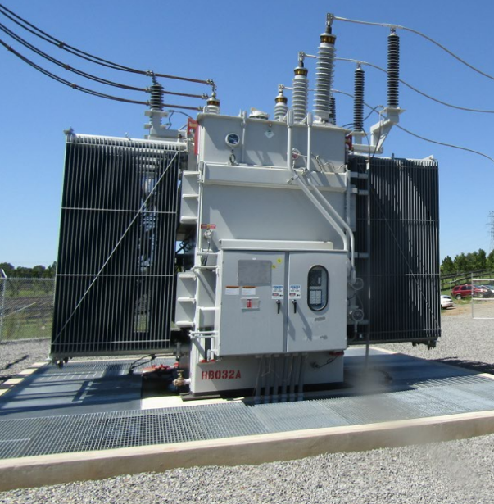
There was a time when most transformer oil was toxic. From 1929 to 1977 polychlorinated biphenyls (PCBs), a man-made alternative to mineral oil, was commonly used as transformer oil instead of mineral oil. However, the toxicity of PCBs was eventually understood, leading to PCBs being banned in the US in 1979. Today, transformers either use mineral oil or vegetable oil, both of which are free of PCBs. Mineral oil is non-toxic to humans, in fact “baby oil” that is used to soothe babies’ skin is a scented mineral oil. Although non-toxic to humans, mineral oil is an environmental contaminate and harmful to aquatic ecosystems, so any release to the environment should be avoided. The potential for negative environmental impact from spilled vegetable oil is much less because these oils are biodegradable, so the time they impact the environment is short-lived. Federal regulations dating back to the Clean Water Act of 1973 require that facilities with significant quantities of oil to prevent pollution of water. The current EPA regulations require that facilities with over 1,320 gallons oil, and with the potential for spilled oil to impact surface water, must develop and implement an oil spill prevention, control and countermeasure (SPCC) plan. While the risk of negative environmental impact from a transformer oil spill/leak cannot be eliminated entirely, these regulations along with standard industry practices, result in a low probability for a substantial spill and a high probability for a quick clean-up response to minimize impact if a spill were to ever occur.
Figure 5. GSU Transformer with Secondary Containment to Capture any Leaked Oil

Toxicity: Operations & Maintenance
Unlike most other electricity generation facilities, photovoltaic systems do not produce any emissions. The only way they could produce emissions is in the case of a fire. The potential human health impacts from contact with smoke from burning PV panels was studied by the International Energy Agency (IEA) PVPS in their first report on human health risk assessment. In that study they did not study ground-mounted PV, presumably because of the extremely low risk of significant fire, but they did investigate the potential health impacts of lead in silicon modules dispersing in smoke from a fire in a building that is covered in PV modules. The study considered several worst-case scenarios for different size buildings and different environments and found no risk of harmful health impacts from the smoke from PV panels.
The only other two aspects of operations and maintenance (O&M) that have raised concerns about toxicity are the fluids used to wash panels and herbicides used to maintain vegetation.
- Panel Washing – Across VA there is ample rain to keep the panels clean. If the panels need to be washed, it would occur infrequently and typically with use of only deionized water and cleaning brushes.
- Herbicides – The industry standard practice for maintaining the vegetation at solar facilities is similar to how most cities maintain their parks, which is they primarily rely on mowing and string trimmers for vegetation management, and use herbicides along fences, in roads, and around some equipment. Parks and solar facilities also use herbicides to strategically remove problem weeds, especially woody weeds, to maintain a healthy cover of the desired species of grasses and other low-growing vegetation. This mode of herbicide use applies significantly less than the herbicide volume commonly applied in VA agriculture. For example, Round-Up-Ready crops are common row crops that have been engineered for the entire field, including the crops, to be sprayed with Round-Up (glyphosate) several times each season. Additionally, farmers applying most types of herbicides to their fields are not required to be certified or licensed, but a VA commercial pesticide applicators license is required to apply any herbicide to a solar facility. At Purdy Solar, the Greensville County solar ordinance requires that the site notify the County prior to application of pesticides and fertilizers.

Sources for Further Reading on Toxicity/End-of-Life:
- International Renewable Energy Agency (IRENA): End-of-Life management: Solar Photovoltaic Panels, June 2016
- Electric Power Research Institute (EPRI): Environmental and Economic Considerations for PV Module End-of-Life Management, December 2018
- EPRI: Feasibility Study on Photovoltaic Module Recycling in the United States, April 2018
- EPRI: Solar Photovoltaics End of Life Management Infographic, March 2021
- National Renewable Energy Laboratory (NREL): A Circular economy for PV system materials, April 2021
- North Carolina Department of Environmental Quality: Final Report on the Activities Conducted to Establish a Regulatory Program for the Management and Decommissioning of Renewable Energy Equipment, January 2021

Electromagnetic Fields (EMF)
Exposure to EMF, or electric and magnetic fields, is a fact of everyday modern life. Electromagnetic fields come in many different frequencies, ranging from grid electricity with a frequency of 60 hertz to x-rays and gamma rays that are billions of billions of times faster. The faster the frequency the stronger the EMF. The EMF coming from grid electricity, including from the inverters, transformers, and AC wires to be used at the Purdy Solar facility, has much lower frequency and therefore much lower energy than the EMF from cell phones, wireless internet, and even radio and TV towers. The solar panels and the wires connecting both of them to the inverters carry direct current (DC) electricity, which has a frequency of zero hertz, and thus produces static electric and magnetic fields. The voltage and current of these circuits are both relatively low, so the electric and magnetic fields they produce are both rather weak. The static magnetic fields the PV panels generate are much weaker than the Earth’s natural static magnetic field, which can be demonstrated by a compass still pointing north when placed near the panels.
Electric fields are created around wires and equipment wherever a voltage exists, however it is easily blocked with common materials such as metal, wood, and soil. The World Health Organization (WHO) in 2005 concluded that there were no substantive health issues related to electric fields (0 to 100,000 Hz) at levels generally encountered by members of the public. The proposed solar project does not produce any voltages higher than the existing power lines, and therefore does not produce any electric fields not generally encountered by members of the public.
Magnetic fields are the other aspect of EMF, and they are created by electric current. Typical Americans are exposed to about 1 milligauss of magnetic field from grid electricity on average during their day, primarily from sources at homes and work. The primary source of magnetic fields in a solar facility are the inverters and the short section of wires between each central inverter and its step-up transformer. To convert direct current to alternating current inverters use a series of switches that turn off and on several thousand times a second, creating EMF in the range of 5 kHz to 100 kHz, which is much faster than the 60 Hz of grid electricity but still much slower than even the lowest frequency radio signals. Also, the energy output of inverters has the highest electrical current of any portion of the solar facility, making the few feet of wire between the inverter and the transformer the source for the strongest magnetic fields in the facility, yet because the strength of a magnetic field decreases dramatically with increasing distance from the source these magnetic fields only extend about 150 feet from the inverter, which is less than the distance from each inverter to the perimeter of the Purdy Solar project, at which point they measure less than 0.5 milligauss. Similarly, the magnetic fields from substations generally do not extend far enough to leave the fence around the substation, so the same can be expected for the Project’s substation.
The bottom line is that the EMF from the Purdy Solar PV system will not leave the solar site boundary, and thus will not increase the EMF exposure of any neighbors. Even if some EMF from the PV facility were to extend beyond the fenced perimeter of the site, there would still be no public health impact because low levels of extremely low frequency (ELF) EMF exposure are not harmful to humans. After extensive study of the potential health impacts of EMF from grid electricity the World Health Organization (WHO) concludes:
“Despite extensive research, to date there is no evidence to conclude that exposure to low level electromagnetic fields is harmful to human health.”

Sources for Further Reading on EMF:
- Electric Power Research Institute (EPRI): EMF and Your Health: 2019 Update and emf.epri.com
- World Health Organization (WHO): www.who.int/peh-emf/about/WhatisEMF

Heat Island Effect
The localized effects of large-scale PV facilities on temperature and moisture are not yet well understood. However, the localized micro-climate effects of large-scale PV facilities are understood well enough to determine that they do not create a heat island effect similar to the well-documented urban heat island effect from dark, massive, surfaces in urban environments, such as asphalt paved streets and parking lots, that cause urban areas to be significantly warmer than the surrounding rural area during the day and night. The changes that solar panels may make to the way land absorbs, reflects, and emits the energy from sunlight are minimal compared to the changes created by buildings, vehicles, and many miles of concrete and asphalt. By comparison, solar panels absorb and reflect a similar amount of solar energy as vegetation and soil. Solar panels are lightweight and cannot store large amounts of thermal energy, and the ground remains covered in vegetation with its natural exposure to air and water.
Initial research into the potential for PV systems to cause a heat island effect have used a variety of techniques, including conceptual energy flow calculations, advanced fluid dynamic computer simulations, and field measurements of temperature., , This research found a range of different effects on temperature, but none indicate that a large PV system could affect the temperature of the surrounding community. Most found that compared to similar undeveloped land the air temperature in a solar facility increases during the day, but the nighttime results were mixed. Some studies found PV sites to be cooler than non-PV sites at night, but others found them to be warmer. Much of this variation is likely explained by the different climates studied but may also be due to the different methods of the studies. Much of the research on solar heat island effect occurred in arid regions of the U.S. southwest where the results are unlikely to translate perfectly to wetter climates in the southeast. In a written statement of evidence Greg Barron-Gafford, leading solar heat island effect researcher, says that he expects that when the area under the PV array is vegetated with grass that the localized heat island effect his research found in dry climates will be greatly reduced.
The available studies agree that the slight increase of air temperature in the PV site dissipates quickly with height and distance from the panels as natural processes remove and spread the heat. As a result, any temperature increase that may occur at the Purdy Solar project during the day will be limited to the site and will not increase the temperature of any of the surrounding community.
Sources for Further Reading on Heat Island Effect:
- EPA: Learn about heat islands: www.epa.gov/heatislands/learn-about-heat-islands

Glare
Photovoltaic panels are designed to absorb, and thus not reflect, the solar energy that they receive. However, when sunlight strikes the glass front of a solar panel at a glancing angle a significant portion of the solar radiation is reflected, which can potentially lead to solar glint (a brief flash) or glare. Glint or glare can temporarily impact a person’s vision, including pilots landing aircraft, or motorists driving vehicles. However, the conditions required for a PV project to create glare rarely occur.

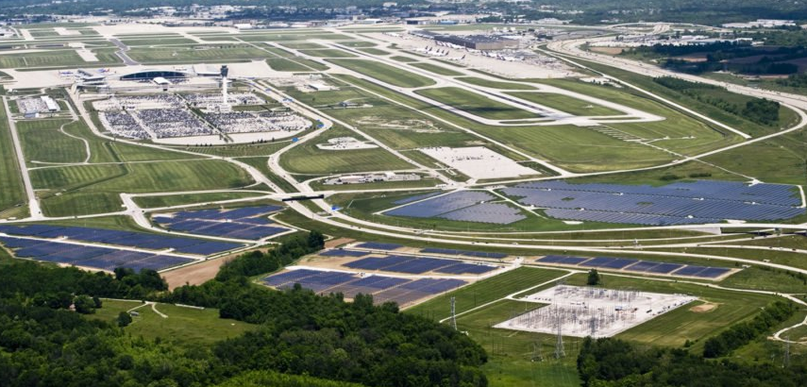
PV facilities, such as Purdy Solar, that utilize single axis trackers to slowly rotate the solar panels to follow the sun have even less potential to create glare because the trackers help avoid a situation where sunlight hits the panels at a glancing angle. Most modern trackers implement an advanced control strategy known as “backtracking” that increases the electricity production of the site by flattening the tilt of the panels early and late in the day to keep the rows of solar panels from shading one another. Backtracking can result in brief periods near sunrise and sunset where the sun strikes the panels at a glancing angle, creating a situation that could result in a few minutes of visible glare at sunrise and sunset. For anyone to see this glare they must be looking across the solar panels in the direction of the rising or setting sun, which is a situation where the sun obviously will create significant glare for the viewer with or without the solar project.
Figure 6. 20 MW PV System at Indianapolis International Airport (Photo source: inhabitat.com)

A clear indication of the lack of glare problems from large ground-mounted PV systems are the PV systems installed on airports across the U.S., including Denver International and Indianapolis International. While there is the potential for a PV system to create glare there is also the ability to predict when and where a system may create glare and incorporate any needed mitigation before construction. The Federal Aviation Administration (FAA) and the U.S. Department of Energy developed specialized solar glare analysis software to predict when and where a PV project may produce glint or glare for sensitive receptors nearby.

In May of 2021, the FAA replaced the long-standing interim solar glare policy with a (final) policy that no longer restricts solar developed on airport property from creating glare visible to pilots. The policy explains that the new acceptance of glare visible to pilots is in recognition that pilots often experience glare during landing from bodies of water and that glare from solar is not meaningfully different. The new policy does still prohibit on-airport PV systems from creating any glare visible in an air traffic control tower. While the FAA policy only applies to PV developed on airport property, it is reasonable to follow the same policy for PV plants sited near airport property.

The closest airport to the Purdy Solar project is the Emporia Greensville Regional Airport (EMV), which is located roughly 7 miles southeast of the site. This airport does not have an air traffic control tower, so there is no chance of glare from the facility impacting air traffic controller. Additionally,
FAA’s jurisdiction to require glare studies of off-airport solar facilities is extremely limited so the FAA does not provide guidance on how far away impacts are possible, however conservative FAA guidance from the early days of solar development when FAA had stronger glare concerns was to conduct a software glare hazard analysis when a PV facility is proposed within 5 nautical miles (5.75 miles) of an airport. With closest airport being over 7 miles away from the project there is no chance for Purdy to create a glare hazard at this airport.

It is also possible for utility-scale PV facilities to cause brief periods of glare visible to motorists driving nearby. However, like pilots, motorists are accustomed to occasionally seeing glare near the rising or setting sun, both from the sun itself and from reflection off flat objects such as a body of water or the windows of a vehicle or building, and motorists regularly adjust safely to this visual challenge. However, the panels must be visible from the driver’s point of view to have any possibility of creating glare. At Purdy Solar, there is a north-south road near both the east and west edges of the facility, however the extensive vegetative buffer along the road frontage and the vegetative buffer around the rest of the perimeter of the PV array areas will block much of motorists’ view of any solar panels and thus block potential glare. Considering the topography of the site and the vegetative buffers, motorists are not expected to experience glare from the proposed project that could cause a glare hazard.

Sources for Further Reading on Solar Glare:
- National Renewable Energy Laboratory (NREL): Webpage on glare impacts from PV www.nrel.gov/state-local-tribal/blog/posts/research-and-analysis-demonstrate-the-lack-of-impacts-of-glare-from-photovoltaic-modules.html
- ForgeSolar: Solar glare analysis software documentation covering solar glare fundamentals www.forgesolar.com/help/

Conclusions
Based on my knowledge of engineering and science, personal experience with PV technology, review of academic research, and review of materials provided by Renewable Energy Services and Palladium Energy about the proposed Purdy Solar PV facility in Greensville County, Virginia, my findings and opinions are summarized as follows:
- The Purdy Solar project will result in a meaningful reduction of regional air pollution.
- The Purdy Solar project will not result in any negative impacts to public health or safety.
- The Purdy Solar project will not increase the temperature of the area surrounding the site.
- The Purdy Solar project is not expected to create any glare hazards or other negative glare impacts.

US Environmental Protection Agency, Public Health Benefits-per-kWh of Energy Efficiency and Renewable Energy in the US: A Technical Report. 2nd Ed, May 2021, www.epa.gov/statelocalenergy/public-health-benefits-kwh-energy-efficiency-and-renewable-energy-united-states
Solar Permit By Rule (9VAC15-60), Chapter 60. Small Renewable Energy Projects (Solar) Permit by Rule, https://law.lis.virginia.gov/admincode/title9/agency15/chapter60/
Photo sources: author, ncre-usa.com, NC DEQ, blueoakenergy.com, solarbuildermag.com, hbc-inc.com, solarprofessional.com, enr.com, dynapower.com, ie-corp.com, ccrenew.com, and landiscontracting.com
Matt Fountain. The Tribune. Fire breaks out at Topaz Solar Farm. July 2015. www.sanluisobispo.com/news/local/article39055539.html
WBMM News 13, Fire breaks out at Jackson Co. solar farm. August 2022, www.youtube.com/watch?v=byE_BpUX2mc
The financial information firm Bloomberg has developed a tiering system for PV module makers based on bankability that is the standard the PV industry uses to differentiate between the hundreds of manufacturers of solar modules on the market. Tier 1 is the highest of three tiers, which are determined by banks’ confidence in a manufacturer’s PV panels as demonstrated by their willingness to supply project financing backed only by the assets of the project. The details are described by BloombergNEF in this document: PV Module Tier 1 List Methodology https://data.bloomberglp.com/bnef/sites/4/2012/12/bnef_2012-12-03_PVModuleTiering.pdf
Smith, D.B., Cannon, W.F., Woodruff, L.G., Solano, Federico, Kilburn, J.E., and Fey, D.L., 2013, Geochemical and mineralogical data for soils of the conterminous United States: U.S. Geological Survey Data Series 801, 19 p., http://pubs.usgs.gov/ds/801/
PV: 12 g of lead (per panel) per 65 ft² (panel footprint of 21.5 ft² / ground coverage ratio of 0.33) = 0.185 g of lead/ft² Soil: 20 mg of lead per kg of soil * 45 kg of soil per ft³ * 2.5 inches (0.208 ft) soil depth * 65 ft² = 12.17 g of lead / 65 ft² = 0.187 g of lead/ft²
P. Sinha, G. Heath, A. Wade, K. Komoto, 2019, Human health risk assessment methods for PV, Part 2: Breakage risks, International Energy Agency (IEA) PVPS Task 12, Report T12-15:2019. ISBN 978-3-906042-87-9, September 2019
“Clean Energy in Michigan” Series, Number 12, Facts about solar panels: PFAS contamination, By Dr. Annick Anctil, https://graham.umich.edu/media/pubs/Facts-about-solar-panels--PFAS-contamination-47485.pdf
OECD is an intergovernmental organization with representatives of 38 industrialized countries. OCED developed the updated definition in response to an international call for “programmes and regulatory approaches to reduce emissions and the content of relevant perfluorinated chemicals of concern in products and to work toward global elimination, where appropriate and technically feasible.” OECD Portal on Per and Poly Fluorinated Chemicals: www.oecd.org/chemicalsafety/portal-perfluorinated-chemicals/
OECD (2021), Reconciling Terminology of the Universe of Per- and Polyfluoroalkyl Substances: Recommendations and Practical Guidance, OECD Series on Risk Management, No. 61, OECD Publishing, Paris. www.oecd.org/chemicalsafety/portal-perfluorinated-chemicals/terminology-per-and-polyfluoroalkyl-substances.pdf
Tamizhmani, G., et al. (2019). Assessing Variability in Toxicity Testing of PV Modules. In 2019 IEEE 46th Photovoltaic Specialists Conference (pp. 2475-2481). Institute of Electrical and Electronics Engineers Inc.. https://doi.org/10.1109/PVSC40753.2019.8980781 Publicly-accessible version: dev-pvreliability.ws.asu.edu/sites/default/files/93_assessing_variability_in_toxicity_testing_of_pv_modules.pdf
P. Sinha, G. Heath, A. Wade, K. Komoto, Human health risk assessment methods for PV, Part 3: Module disposal risks, International Energy Agency (IEA) PVPS Task 12, Report T12-16:2020. ISBN 978-3-906042-96-1, May 2020
Green Tech Media, Landfilling Old Solar Panels Likely Safe for Humans, IEA Research Suggests, April 2020, www.greentechmedia.com/articles/read/solar-panel-landfill-deemed-safe-as-recycling-options-grow
Environmental Protection Agency, webpage: Overview of the Spill Prevention, Control, and Countermeasure (SPCC) Regulation, www.epa.gov/oil-spills-prevention-and-preparedness-regulations/overview-spill-prevention-control-and
P. Sinha, G. Heath, A. Wade, K. Komoto, 2018, Human Health Risk Assessment Methods for PV, Part 1: Fire risks, International Energy Agency (IEA) PVPS Task 12, Report T12-14:2018, https://iea-pvps.org/wp-content/uploads/2020/01/HHRA_Methods_for_PV_Part1_by_Task_12.pdf
WHO factsheet: Electromagnetic fields and public health, Exposure to extremely low frequency fields, June 2007, www.who.int/peh-emf/publications/facts/fs322/en/
World Health Organization (WHO), webpage: Electromagnetic Fields – Typical exposure levels at home and in the environment, www.who.int/peh-emf/about/WhatisEMF/en/index3.html
Study of Acoustic and EMF Levels from Solar Photovoltaic Projects. Tech Environmental, Inc., December 2012, www.masscec.com/study-acoustic-and-emf-levels-solar-photovoltaic-projects
www.niehs.nih.gov/health/materials/electric_and_magnetic_fields_associated_with_the_use_of_electric_power_questions_and_answers_english_508.pdf
World Health Organization (WHO), webpage: Electromagnetic Fields – Summary of health effects, www.who.int/peh-emf/about/WhatisEMF/en/index1.html
Broadbent, Ashley & Krayenhoff, Eric & Georgescu, Matei & Sailor, David. (2019). The Observed Effects of Utility-Scale Photovoltaics on Near-Surface Air Temperature and Energy Balance. Journal of Applied Meteorology and Climatology. 58. 10.1175/JAMC-D-18-0271.1.
Barron-Gafford, G. A. et al. The Photovoltaic Heat Island Effect: Larger solar power plants increase local temperatures. Sci. Rep. 6, 35070; doi: 10.1038/srep35070 (2016).
V. Fthenakis and Y. Yu, "Analysis of the potential for a heat island effect in large solar farms," 2013 IEEE 39th Photovoltaic Specialists Conference (PVSC), Tampa, FL, 2013, pp. 3362-3366, doi: 10.1109/PVSC.2013.6745171.
G. Barron-Gafford, Statement of Evidence by Greg Barron-Gafford on Solar Heat Islanding Issues, May 2018, www.planning.vic.gov.au/__data/assets/pdf_file/0024/126555/301-Expert-Witness-Statement-of-G-Barron-Gafford-PVHI-May-2018-Lemnos.pdf
“Federal Aviation Administration Policy: Review of Solar Energy System Projects on Federally-Obligated Airports”, https://www.federalregister.gov/documents/2021/05/11/2021-09862/federal-aviation-administration-policy-review-of-solar-energy-system-projects-on-federally-obligated
NC Template Solar Ordinance, Appendix F: Airports. https://nccleantech.ncsu.edu/wp-content/uploads/2018/06/NC-Template-Solar-Ordinance.pdf

